FM(12)090 Rev5
Working Group FM

75th Meeting
Minsk, 24 – 28 September 2012
Date issued: | 26 September 2012
Source: | ECO
Subject: | Summary of the questionnaire on the implementation of BFWA (Broadband Fixed Wireless Access)  in the frequency band 5 725-5 875 MHz according to  ECC Recommendation (06)04
Y
Group membership required to read? (Y/N)

Summary

This questionnaire was sent out from the Office on 30 April 2012. The official deadline was the 20 June 2012.

By 18 September 2012, a total of 38 administrations provided an answer to the questionnaire.

All the responses are contained in the annex attached to this summary.

CEPT/ECC adopted ECC Recommendation (06)04 on "Use of the band 5 725-5 875 MHz for Broadband Fixed Wireless Access (BFWA)" in 2006. This Recommendation defines the provisions and parameters for BFWA systems using spectrum within the frequency band 5 725-5 875 MHz.

WG FM had decided in February 2008 to adopt a questionnaire regarding the implementation of BFWA in the 5.8 GHz band. The responses to this questionnaire were discussed during the 63rd WG FM meeting in Brussels, May 2008. It was assumed that the extent of implementation has increased within CEPT since 2008. Therefore, and also because the 5.8 GHz band (5 855-5 875 MHz) is currently under study as a candidate band for Broadband Direct-Air-to-Ground Communications (Broadband DA2GC), updated information on the implementation of BFWA was considered to be beneficial.

WG FM decided during its 74th meeting in Bern in April 2012 that a questionnaire on the use of the 5.8 GHz BFWA band should be sent out to CEPT administrations and via the WG FM reflector by ECO. An additional question defined by PT FM48 regarding the status of BFWA implementations in the respective country (either as protected service or as secondary, unprotected application) was also sent by ECO to those administrations which have already implemented BFWA.

Proposal

WG FM is invited to consider the responses and the summary for necessary actions to be taken on the subject.

FM48 is invited to provide an assessment based on the results of the questionnaire and make a proposal to WG FM with regard to the impact on the candidate band for Broadband Direct-Air-to-Ground Communications (Broadband DA2GC).

- Responses

Replies were received from 38 administrations by 18 September 2012 (countries in bold).

Albania  Andorra  Austria  Azerbaijan  Belarus  Belgium  Bosnia Herzegovina  Bulgaria  Croatia  Cyprus  Czech Republic  Denmark  Estonia  Finland  France  Georgia  Germany  Greece  Hungary  Iceland  Ireland  Italy  Latvia  Liechtenstein | Lithuania  Luxembourg  Macedonia  Malta  Monaco  Montenegro  Moldova  Norway  Polen  Portugal  Romania  Russian Federation  San Marino  Serbia  Slovak Republic  Slovenia  Spain  Sweden  Switzerland  The Netherlands  The United Kingdom  Turkey  Ukraine  Vatican City

Countries in RED: countries where no information is available
14 countries have implemented BFWA via the whole frequency range from 5 725-5 875 MHz: Estonia, Iceland, Slovenia, Montenegro, Macedonia, Moldova, Norway, Bosnia Herzegovina, Russian Federation, Hungary, Ireland, Georgia, Andorra, and Portugal.

11 countries have implemented BFWA in parts of the frequency range from 5 725-5 875 MHz:
Spain, Finland and the United Kingdom: 5 725-5 795 MHz and 5 815-5 850 MHz;
Switzerland, Liechtenstein, and Denmark: whole band except RTTT DSRC (Road Transport and Traffic Telematics – Dedicated Short Range Communications, mostly used for RTS – Road Tolling Systems);
in 5 795-5 815 MHz;
Germany: 5 755-5 875 MHz;
Belarus: 5 725-5 785 MHz;
Lithuania and Ukraine: 5 725-5 850 MHz;
Greece: 5 725- 5795 MHz.

According to the implementation status in the document database as well as information in EFIS, three countries which did not submit an answer to the questionnaire (Belgium and Romania) have also implemented ECC Recommendation (06)04 (BFWA). Latvia has implemented BFWA in 5905-5925 MHz.

Therefore, 27 countries have currently implemented BFWA in all or parts of the frequency range 5 725-5 875 MHz.

13 countries provided an answer indicating that they have not implemented BFWA according to ECC/REC/(06)04: Austria, Netherlands, Italy, Cyprus, Luxembourg, Czech Republic, France, Serbia (planned), Slovak Republic (planned), Croatia, Malta (planned), and Sweden (planned), Turkey. Furthermore, one country indicates via the implementation status in the documentation database that they have not implemented ECC/REC/(06)04 (Bulgaria).

Therefore, 14 countries have not implemented BFWA in the frequency range 5 725-5 875 MHz, however, 4 of these countries plan the implementation of BFWA. A considerable number of countries of those which have implemented the ECC/REC/(06)04 or having plans for implementation reported a lack of demand for BFWA in their country so far.

Information is missing/no information has been received from 5 countries: Azerbaijan, Vatican City, Monaco, Poland, and San Marino. Albania indicated that the subject is under study.

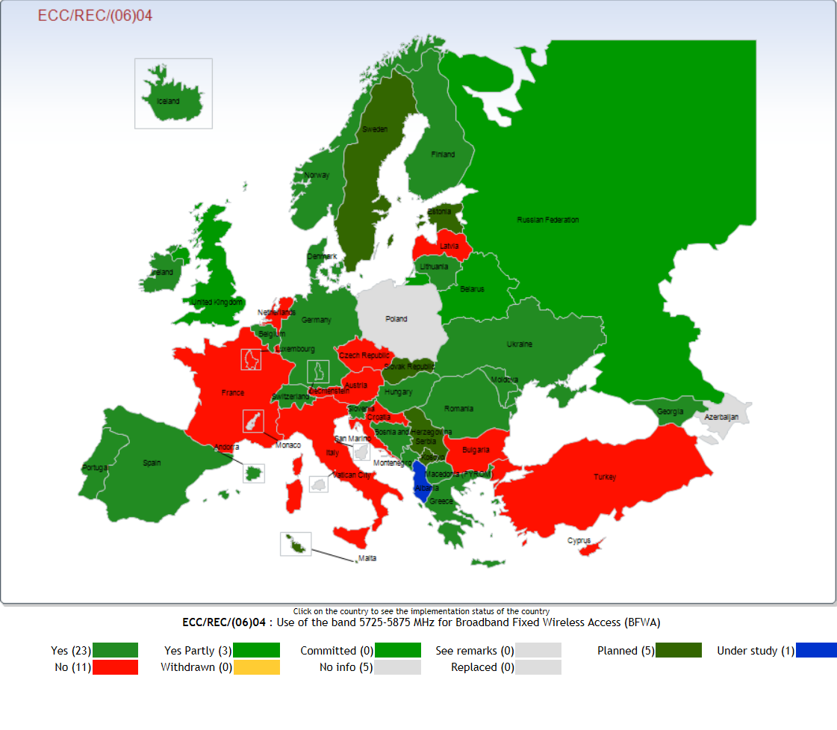
Note: Latvia has not implemented the ECC/REC/(06)04 but has implemented BFWA in 5905-5925 MHz. Estonia has implemented BFWA in mid 2012.

1 Existing Implementation Information BFWA in 5 725-5 875 MHz

Individual authorisation regimes:

All except four countries which have implemented BFWA follow the ECC Recommendation (04)04 which recommends that administrations should consider applying simplified authorisation procedures for BFWA in this band, e.g. licence-exempt or light licensing regime. Only the Russian Federation, Estonia and Belarus use individual, link-by-link authorisations. Montenegro also uses individual authorisations but reported a lack of demand (no current usage). Moldova also indicated full implementation but without determination of the authorisation regime because so far no demand was expressed. If demand would materialise, Montenegro would investigate conditions that should be met to make the range accessible for use in the manner which will present the highest possible (economic) value both from the aspect of users as well as the State Montenegro.
Implementation plans:

Serbia plans implementation under general authorisation regime, but with a requirement for registration or notification. The Slovak Republic plans implementation outside of the RTTT DSRC frequencies and under general authorisation. Malta and Sweden also plan implementation, but have not determined the authorisation regime.

Light licensing:

Several countries already make use of registration/ notification procedures (light licensing) which also make it necessary to provide location details about the central station or even clients (Portugal – not completely settled yet, United Kingdom, Germany, Greece, Ireland, Macedonia – in some relevant regions), and Ukraine (central stations need to be notified).

General authorisations:

The majority, i.e. all other countries which have implemented BFWA, do this based on ECC/REC/(06)04 and using exemption from individual licensing.

Technique neutrality:

Only Hungary (OFDM – Orthogonal Frequency Division Multiplex) and the Russian Federation (OFDMA- Orthogonal Frequency Division Multiple Access or TDMA – Time Division Multiple Access) limit BFWA regulation to usage of certain technology(ies). No other answers from those who implemented BFWA make any technology-based restrictions.

Nomadic Use:

Only the Russian Federation, the United Kingdom and Belarus do not allow nomadic use. In all other cases, it is explicitly allowed or virtually allowed by lack of description, definition or not specifying an exclusion of nomadic use. Malta (planned implementation) indicates that nomadic use will not be allowed.

Other restrictions:

Germany limits the use of BFWA to the provision of public services only, the frequency band 5 755-5 875 MHz has been made available for public services only, i.e. for use by commercial operators of BFWA systems. The location of the BFWA systems (district or self-governing town) has to be notified. Every operator can use the whole spectrum everywhere.

The majority of countries that have implemented BFWA do not report about special restrictions or deviations from the recommendations in ECC/REC/(06)04, although some allow the use of higher power in certain cases for point-to-point links such as rural areas (e.g. to support longer operating range): Iceland, UK, Ireland, Hungary, Bosnia Herzegovina (unprotected links, i.e. in case of interferences, then the power needs to be adjusted). Norway allows in general up to 25 mW; however, use of the frequency bands 5 725-5 795 MHz and 5 815-5 850 MHz is authorised for a point-to-point operation with a maximum permitted radiated power of 200 W e.i.r.p. The maximum permitted power supplied to antennas is 1 W. Maximum mean spectral density shall be limited to 10 W/MHz e.i.r.p. in any 1 MHz band.

The regulation in the Ukraine requires a special block assignment (two blocks of 30 MHz and one block of 60 MHz).

Why not allowing BFWA in all or parts of the 5 725-5 875 MHz frequency range?

18 countries indicated why BFWA is not allowed in all or parts of the 5 725-5 875 MHz range:

Spain: 5 795-5 815 because of RTTT DSRC and 5 850-5 875 MHz because of ITS (Intelligent Transport Systems) applications;

Austria: Protection of RTTT applications against interference from BFWA is not guaranteed. Parts of this band are also used by military radar on an exclusive basis. “With regard to the expected incompatibility of BFWA with RTTT applications according to the “Directive 2004/52/EC of the European Parliament and of the Council of 29 April 2004 on the interoperability of electronic road toll systems in the Community“ in the band 5 795 – 5 815 MHz, the Austrian administration refers to its letter to the ERO from 7 July 2006 which was submitted in the framework of public consultation of Draft ECC recommendation (06)04. As outlined in this letter, it is of major importance that RTTT applications are protected from harmful interference. Any compromise of the proper and interference-free functioning of the RTTT system will possibly lead to trials before legal courts, with many millions of EURO at stake. As a possible way forward, it could be envisaged to notch-out the sub-band used by the RTTT system in accordance with ERC/REC 70-03 (5 795 – 5 815 MHz) with additional guard bands (to be defined). Information provided by manufacturers of BFWA systems showed, that this could be a viable approach. However, bearing in mind the European dimension of the introduction of BFWA, this solution should be implemented on a harmonised pan-European basis.“

Netherlands: There has not been a demand in the Netherlands;

Italy: The band is almost completely used by Ministry of Defence. The use of this band by other applications, in particular by Broadband DA2GC, could be seriously harmful to military applications;

Switzerland and Liechtenstein: 5 795 – 5 815 MHz excluded because of RTTT;

Cyprus: This frequency band is allocated on a primary basis for fixed-satellite applications and radiolocation. The use of the band for BFWA has not been harmonised at EU level;

Denmark: The band 5 795-5 815 MHz shall not be used (protection of RTTT);

Luxembourg: Luxembourg has not implemented ECC REC (06)04 and has currently not the intention to allow BFWA in the 5.8GHz band. Any use of the band, such as BDA2GC, shall not impact satellite service in this band (e.g. by requiring a protection of BDA2GC from satellite up-links);

Lithuania: no demand for whole band;

Czech Republic: countrywide deployment of Road Toll System 5.8 GHz;

France: The protection of frequency hopping radars in the 5 725-5 850 MHz band is not ensured. Further practical testing is necessary to assess the efficiency of DFS (Dynamic Frequency Selection mechanism) with regard to frequency hopping radars in this band;

Belarus: military radio applications, radio relay links;

UK: (5 795 – 5 815 MHz not permitted to be used to protect RTTT and 5 850 – 5 875 MHz not permitted to be used to protect FSS uplinks)

Germany: The sub band 5 725-5 755 MHz is not available because of the protection requirements for military radio applications within the radiolocation service;

Slovak Republic: outside of RTTT DSRC frequencies;

Croatia: Other usage of the band; bands below used for BWA; Bands below are allocated for BWA so we don’t see a need for additional allocation for BWA on general licence basis in 5.8 GHz band;

Sweden (implementation planned): not intended to use the upper part of the band designated for non-security related ITS (Intelligent Transport Systems) for BFWA.

Latvia has implemented BFWA in the frequency range above, in 5905-5925 MHz.

Proposals made regarding issues to be addressed by the ECC:

6 countries made 6 different proposals:

Cyprus: CEPT/ECC should address mainly compatibility issues with existing applications in the band and also the possibility of harmonizing the use of the band for BFWA through an ECC decision;

Czech Republic: The Czech Republic has deployed nationwide electronic RTS (Road Tolling System – RTTT DSRC) which has been operated since 2007. There is still no clear situation with possible coexistence with BWA, specifically in close proximity to motorways and carriageways highways and roads of the first class (speed roads);

France: The difficulties expressed by France for this band are based on the insufficient protection afforded to frequency hopping radars operating in the whole range 5 250-5 850 MHz taking into account current problems in implementing DFS mechanism;

Belarus: The problem of sharing between BFWA and Radio Relay stations in this band;

Germany: Assuming that much more administrations have implemented BFWA in the 5.8 GHz band since 2008, an European Common Allocation to the Fixed Service (primary) should be added in column 2 of the European Common Allocations Table (ERC Report 25, Lille / 2011) for the frequency range 5 725-5 875 MHz (such an allocation currently only available for the frequency range above 5 850 MHz);

Ireland: Congestion within the 5.8 GHz band in certain areas can be problematic, particularly in the urban environment.

Quantity of usage (Current deployment data):

Very limited deployment data was provided. One should however take into account that many administrations have no deployment data when using general authorisations without any notification or registration needs:

Georgia: Operators are required to submit to the Commission in each month so-called “Statistics Information” in which, among other data, service area (town, district and etc.) should be indicated. There should be about 70 operators in the whole territory of Georgia;

Germany: The district or self-governing town in which a BFWA system is operated is known because of the light licensing procedure. So far we have got notifications from 69 BFWA operators for 202 different districts / self-governing towns. Assuming that there is only 1 central station in every district / self-governing town, there are (at least) 202 central stations currently in operation in Germany. BFWA was operated in 11 districts / self-governing towns in the year 2008 (response to the questionnaire from 2008);

Ireland: about 90 central stations;

Ukraine: around 100 central stations notified all over the Ukraine.

Russian Federation: indicates that quantity will be presented later in a meeting.
From ECC Report 173 (2011) (under the scope of Fixed Service):
From 5.85 to 5.95, some use is indicated, mostly for P-MP (Point-to-Multipoint). The licensing regime appears to be mostly link-based. Few countries indicated a significant use, including the Russian Federation (1400 Point-to-Point (P-P) links, 600 PMP Base Stations, infrastructure and broadcasting).

UK:
Information is available on the topologies used, e.g. P-P, P-MP, repeater, mesh. But not on which end of the link is the central station and which is CPE. Any number of “terminals” (a terminal being a generic term for any type of transmitting station) can be deployed under a single light licence. So the number of licences is not a precise indicator of numbers of equipment deployed.

However, the estimate is that about 1000 terminals have been registered in total in the UK. The most popular use tends to be for P-P links (so no central station as such).

Compared with figures provided in RSCOM 07-06 (2007): UK: about 350 CSs (Central Stations) (P-MP), 4500 TSs (Terminal Stations), 420 P-P stations, this shows that the market for BFWA in the UK is not growing. This is in line with one recent market study has been found in the public domain from, 2010 Senza Fili Consulting) :

Excerpts:

<<Fixed WiMAX as a niche technology. WiMAX operators worldwide—and especially the large ones with better access to funding—have largely shifted their support to Mobile WiMAX, leaving Fixed WiMAX to serve business customers or provide service in rural areas. Some smaller operators are transitioning from Fixed WiMAX to Mobile WiMAX as well. We expect the market for Fixed WiMAX to keep growing, with 1.9 million subscribers in 2009 and reaching 3.6 million in 2014 (worldwide, Western and Easter European part 4% and 13% respectively in 2014, i.e. in total roughly 600 000 subscribers, but at a slower pace of growth than that of Mobile WiMAX, so that Fixed Mobile’s share of total WiMAX subscribers in 2009 will shrink to 4% by 2014.>>

Typical applications for BFWA are: link to WiFi hot spots, business customer fixed wireless access systems, rural areas. All these niches under pressure, i.e. replacement by other terrestrial infrastructure (fixed and mobile).

This may lead to an average usage density assumption over Europe of not exceeding 0.1 stations per square kilometer.

International coordination:

Only 4 administrations provided a statement:

Belarus: So far international coordination procedure is used based on the HCM-Agreement;

Russian Federation: Procedures in accordance with ITU-R Radio Regulations as well as bilateral and multilateral Agreements with neighbouring countries.

Ukraine: in accordance with Article 9 of Radio Regulation.

Norway: The power flux density at the border between Norway and neighbouring states shall not exceed -122.5 dB/m2 measured with a reference bandwidth of 1 MHz unless otherwise determined in a co-ordination agreement.

Additional question: How do you consider the regulatory status of BFWA at 5.8 GHz in your country? Do you consider it as a radio application under the scope of a radio service (e.g. Fixed Service) or differently (e.g. similar to a secondary application)? Please explain why you have decided in either way.

14 answers were received from administrations having implemented BFWA or planning BFWA implementation. From all the answers from the questionnaire, it seems clear that some administrations see BFWA as under the Fixed Service (Spain, Germany, Russian Federation, Belarus). Montenegro keeps the option to see it under the Fixed Service ( “…in the manner which will present its highest (economic) value both from the aspect of users as well as the State Montenegro”).

Estonia:

Use of BFWA at 5.8 GHz in Estonia is planned to be as radio application under the scope of a
Fixed Service on a secondary basis.
Denmark:
According to the Danish legislation the band 5 725-5 875 MHz can be used - on a licence- exempted and non-protected basis - for WAS/LAN. This use is not protected against interference from other services, such as ITS which is also using part of the this band. If CEPT should decide to use part of the band for DA2GC, this service will NOT be implemented in Denmark in this band.
Lithuania:
Taking into account that the band 5 725-5 875 MHz is not allocated to FIXED service in the Table of Frequency Allocations (Section 5 of RR) the right wording for BFWA regulatory status in Lithuania is „The secondary application on non-interference basis “. The similar wording we have in our legislation concerning the band 5 725-5 850 MHz: “Wireless access systems, including <...> Broadband Fixed Wireless Access (BFWA) devices, are used on a non-interference basis.“
Spain:
We are considering BFWA in 5725-5875 MHz as radio application as fixed service for FWA and mobile service for NWA/MWA. In both cases, under secondary basics in the ISM band and exempt from individual licensing.
Slovenia:
BFWA is treated as secondary service (licence free) with note "BFWA under non-interference conditions only." and under conditions in ECC/REC(06)04.
Switzerland/Liechtenstein:
The status is for Switzerland: licence exempt, for Liechtenstein: General authorisation
Operation on non-interference basis / non-protection basis (secondary status).
Germany
BFWA at 5.8 GHz is considered in Germany as a radio application under the scope of the Fixed Service (primary status), see frequency usage plan (August 2011). BFWA is a radio application comparable to BWA or to MFCN for which also the regulatory frame conditions of radio services (within the meaning of Article 1 of the ITU Radio Regulations) are relevant.

UK:
We license these as: “Licences shall be issued on a non-protection and non-interference basis” In effect it is a light licence. We decided to license in this way to give the maximum freedom to licensees while having the minimum burden to the licensing authority. You are welcome to pass on to FM48/PT44 the information we state on our website, along with our response to the questionnaire. http://licensing.ofcom.org.uk/radiocommunication-licences/fixed-wireless-access/ In particular the f.a.q. and the notes to the National Interface requirement noted in this link.
Montenegro:
The Allocation Plan defines the use of this band for BFWA systems in line with ECC/REC/(06)04; however up to this date there was no official expression of interest for its use, although interest was expressed in the previous period for the use of this band in a similar manner. As the 5.8 GHz range belongs to the range that requires an approval, we will enter the development of the Allotment Plan in order to more closely define the conditions of its application, following our regulations, ECC/REC/(06)04 recommendation and ECC Report 68.
Following the adoption of the Allotment Plan which would define the manner of use in a way described above, all conditions would be met to make the range accessible for use in the manner which will present its highest value both from the aspect of users as well as the State of Montenegro.
Portugal
5.8 GHz (additional question): we are still analysing the BFWA framework; we expect the corresponding status to be either secondary or on a “non-interference/non-protection” one (Short Range Device - like).
Hungary
According to national regulation BFWA systems in the 5,8 GHz band can be operated on a non-interference, non-protected basis. Based on ECC Rec.(06)04 Hungary would like to support the development of new BFWA systems using simplified authorisation regime (license exempt).
Bosnia Herzegovina
This band was basically „opened“ as fully licence-exempt, i.e. it must not cause and cannot claim protection from interferences, thus there is no info on actual use (number of central stations or similar).
Belarus
Regarding to BFWA in the 5.8 GHz range in BLR it is considered a radio application under the scope of Fixed Service.
Russian Federation:
From ECC Report 173 (2011) (under the scope of Fixed Service):
From 5.85 to 5.95, some use is indicated, mostly for P-MP. The licensing regime appears to be mostly link-based. Few countries indicated a significant use, including the Russian Federation (1400 P-P links, 600 P-MP Base Stations, infrastructure and broadcasting).
Finland:
5.8 GHz BFWA is licence exempt (secondary basis) and the technical parameters are as given in Rec(06)04. Relevant regulation is FICORA Regulation 15 on "collective frequencies for licence-exempt radio transmitters and on their use (2011/337/FIN)"
http://www.ficora.fi/en/index/saadokset/maaraykset/radioliikenne.html

