Pursuant to Article 39, paragraph 1 and Article 32, paragraph 3, in conjunction with Article 31 and Article 37, paragraph 1, items a) and c) of the Law on Communications ('Official Gazette of BiH', No. 31/03, 75/06, 32/10 and 98/12) and Rule 49/2009 Allocation and Utilization Plan for the Radio Frequency Spectrum in BiH ('Official Gazette of BiH', No. 78/10), the Council of the Communications Regulatory Agency at 36th session held on April 23, 2018 adopted the:

Rule 85/2018
on the use of radio frequency bands 3400-3600 MHz and 3600-3800 MHz for MFCN

Article 1
(Subject)
This Rule prescribes the method of using radio frequency bands 3400-3600 MHz and 3600-3800 MHz for mobile/fixed communication networks (MFCN) in Bosnia and Herzegovina on a technologically neutral basis.

Article 2
(Terms and definitions)
For the purposes of this Rule, terms and abbreviations are used with the meanings as follows:

- MFCN (Mobile/Fixed Communication Networks) are mobile/fixed communication networks including IMT (International Mobile Telecommunications) and other communication networks in the mobile and fixed service;
- BEM (Block Edge Mask) is an emission mask defined as a frequency function in relation to the edge of a block licensed to one operator; it consists of in-block and out-of-block components that specify allowed emission levels on frequencies inside and outside the licensed block;
- The guard band is the frequency band applied to reduce unwanted emissions to adjacent ranges or blocks assigned to other operators;
- The transitional region is an region from 0 to 5 MHz and 5 to 10 MHz below and above the block assigned to the operator;
- EIRP (Equivalent Isotropic Radiated Power) is the total power that would be emitted by the hypothetical isotropic antenna to obtain a signal of the same magnitude as the current source in the direction of the strongest antenna radiation;
- TRP (Total Radiated Power) is the actual power output from the antenna connected to the active transmitter; is defined as the integral by the time of averaged power density calculated in all directions over the radiation sphere;
- Synchronized TDD is a TDD in two different networks in which a compatible frame structure is configured, a synchronized start of the frame and no simultaneous transmission on the uplink and downlink.

Article 3
(Frequency arrangement)
- The frequency arrangement in the bands 3400-3600 MHz and 3600-3800 MHz is a TDD distribution based on whole multiple of 5 MHz block, according to the graphic representation in Figure 1.
- The size of the assigned block is determined by the license issued for the given geographical area.

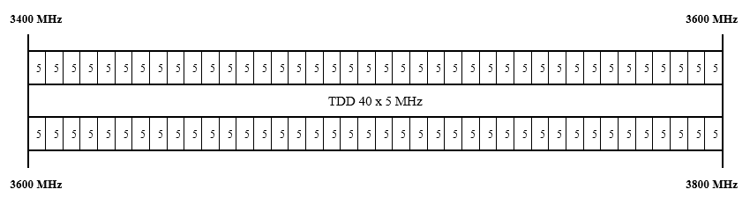
Figure 1: Referential frequency arrangement

Article 4
(Technical requirements for base stations)
- The technical requirements for the use of MFCN base stations are defined by a BEM mask with EIRP limits inside and outside the assigned block (Figure 2).
- The power limit for individual BEM elements is given in the table below:

BEM element | Power limit
Assigned block | 68 dBm/5 MHz per antenna *  4 dBm/5MHz per cell in adjacent sub-blocks of 5 MHz in non-synchronized networks  for the femto base station, power control is mandatory
Transitional region  -5 to 0 MHz from lower block edge  0 to 5 MHz from upper block edge  -10 to -5 MHz from lower block edge  5 to 10 MHz from upper block edge | Min (P_{max} - 40, 21) dBm/5 MHz  EIRP per antenna  Min (P_{max} - 43, 15) dBm/5 MHz  EIRP per antenna
Spectrum outside of the assigned block and transitional region (baseline)  for synchronized TDD blocks  for unsynchronized TDD blocks | Min (P_{max} - 43, 13) dBm/5 MHz  EIRP per antenna  -34 dBm/5 MHz EIRP per cell
Spectrum below 3400 MHz  assigned to radiolocation systems | from -59 to -50 dBm/MHz EIRP
* The value is not strictly limiting, but is recommended and will be applied in the case of unwanted emissions to the adjacent block assigned to another operator.

P_{max} – maximum carrier power measured as EIRP

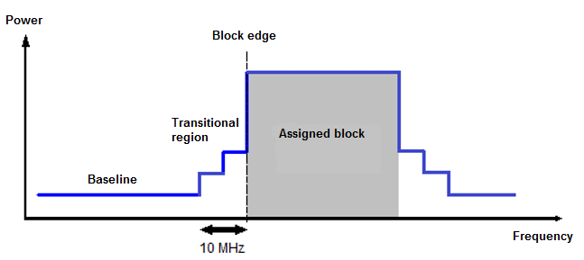

Figure 2: BEM mask

Article 5
(Use of unsynchronized TDD networks)
- Uninterrupted operation of unsynchronized networks on adjacent TDD blocks in the same geographical area is ensured under the following conditions:
- introducing a minimum 5 MHz guard band between adjacent blocks assigned to different operators (the guard band is determined by the Agency when granting licenses for a specific geographical area);
- using adjacent restrictive sub-blocks of 5 MHz at the edge of blocks assigned to different operators with EIRP limit of 4 dBm/5MHz per cell;
- no guard band and restrictive sub-blocks if operators provide the EIRP limit of the baseline from table in Article 4 of this Rule at the edge of its own block.
- Within the guard band and restrictive sub-blocks referred to in paragraph (1) of this Article, the EIRP limits for the transitional region shall apply from the table in Article 4 of this Rule.
- For the operation of unsynchronized networks on adjacent blocks in the same geographical area, any less restrictive conditions or internal guard bands that the operators agree with by bilateral agreement are allowed.

Article 6
(Use of synchronized TDD networks)
- For the operation of synchronized networks on adjacent TDD blocks in the same geographical area, no external guard bands at the edge of the assigned blocks are applied.

- For synchronized TDD networks, the EIRP limit defined for the transitional region shall be applied within the adjacent block assigned to another operator.

Article 7
(Technical requirements for terminal stations / user equipment)
- The upper limit for the power of the terminal station / user equipment in the assigned block is 25 dBm.
- The power limit referred to in paragraph (1) of this Article is EIRP for terminal station designed to be fixed or installed and as TRP for terminal station designed to be mobile or nomadic.
- Tolerance up to +2 dB is included in the limit referred to in paragraph (1) of this Article for work under extreme operating speed or environmental conditions (multipath, poor line-of-sight, etc.).
Article 8
(Coexistence of MFCN stations)
- The permitted levels of interference for different types of base stations are:
Macro base station: -108 dBm/5 MHz
Micro base station: -105 dBm/5 MHz
Pico base station: -100 dBm/5 MHz
Femto base station: -100 dBm/5 MHz

- For macro base stations, the mean field strength produced by the cell must not exceed 32 dBµV/m/5 MHz at the height of 3 m above the ground level at the borderline of the assigned area.
- For different sizes of assigned blocks, the field strength in paragraph (2) of this Article is corrected by adding a value of 10 x log (block size in MHz / 5 MHz).
- For coexistence with other services and resolution of disturbances, valid CEPT and ITU recommendations and coexistence reports will apply.

Article 9
(Border coordination)
- Border coordination with neighboring countries based on preferential frequencies shall be defined by separate agreements between the Agency and administrations of neighboring countries, as appropriate.
- Unsynchronized MFCN TDD systems may be used without coordination and special agreements with neighboring countries if the mean field strength of each cell does not exceed 32 dBµV/m/5 MHz at the height of 3 m above the ground level at the borderline.
- MFCN TDD systems synchronized along the border or implemented as 'only downlink' on both sides of the border may be used without the coordination of neighboring countries if the mean field strength of each cell of the base station does not exceed 67 dBµV/m/5 MHz at a height 3 m above the ground level at the borderline and a value of 49 dBµV/m/5 MHz at the height of 3 m above the ground level at a distance of 6 km within the neighboring country.
- In the case of the use of a TDD from one and the FDD system on the other side of the border, a mean field strength of 32 dBµV/m/5 MHz is applied at the height of 3 m above the ground level at the borderline.
- For different sizes of assigned blocks, the field strengths in paragraphs (2), (3) and (4) of this Article are corrected by adding a value of 10 x log (block size in MHz / 5 MHz).

Article 10
(Principles of assignment)
- The basic principles for granting the license are:
- Licence for a block is assigned for the territory of Bosnia and Herzegovina or in the area of ​​network groups on the basis of a public call published by the Agency (network group: 030 Central Bosnia Canton, 031 Posavina Canton, 032 Zenica-Doboj Canton, 033 Canton Sarajevo, 034 Canton 10, 035 Tuzla Canton, 036 Herzegovina-Neretva Canton, 037 Una-Sana Canton, 038 Bosnian Podrinje Canton, 039 West Herzegovina Canton, 049 Brčko District BiH, 050 Mrkonjić Grad, 051 Banja Luka, 052 Prijedor, 053 Doboj, 054 Šamac, 055 Bijeljina, 056 Zvornik, 057 East Sarajevo, 058 Foča, 059 Trebinje);
- Notwithstanding point a), the network groups 054 Šamac – 055 Bijeljina – 031 Posavina Canton – 049 Brčko District BiH make up the area which is assigned a unique licence for a block;
- With a Public call, the Agency announces which frequency blocks are allocated for the area of ​​Bosnia and Herzegovina and which for the areas of network groups, as well as conditions of the grant;
- The range of 3400-3600 MHz is the preferred range for mobile communications networks with use in the territory of Bosnia and Herzegovina;
- If a greater number of applications are submitted than the number of available radio frequency blocks for the territory of Bosnia and Herzegovina or a network group, the Agency will carry out the procedure which will determine which operator best fulfills the requirements for obtaining a licence.
(2) Blocks intended for state authorities for use are not subject to public calls.

Article 11
(Validity of licence)
- A block licence shall be issued for 10 years, and by issuing the licence, the holder shall be entitled to use the radio frequency block granted pursuant to this Rule and the obligations arising therefrom.
- The term of validity of a licence may be changed by the Agency's decision if it is in accordance with the international recommendations and the Allocation and utilization plan for the Radio Frequency Spectrum in BiH.

Article 12
(Licence for a base station in the assigned block)
- Prior to installing and operating a base station using frequencies from the assigned radio frequency block, the licence holder of the frequency block shall apply for a base station licence issue.
- The application for issuing a base station licence shall be made in accordance with the rules of the Agency.
- A licence for a base station operating in a given block shall be issued for the period of validity of the licence for the use of the assigned radio frequency block.
- Notwithstanding paragraph (1) of this Article, for base stations of mobile communication networks used in the area of Bosnia and Herzegovina, the Agency shall not issue individual licences but may request from the operator the submission of reports with specified base station parameters in the manner and the form specified by the Agency.
- Notwithstanding paragraph 1 of this Article, the state authorities shall not apply for the issuance of individual licences for base stations, but by a separate agreement with the Agency regulate the use of frequency blocks in accordance with Article 1, paragraph 3 of the Law on Communications of BiH.
Article 13
(Cessation of validity)
On the date of entry into force of this Rule, Rule 74/2014 on the Use of the Radio Frequency Ranges 3400-3600 MHz and 3600-3800 MHz ('Official Gazette of BiH,' No. 99/14) shall cease to be valid.
Article 14
(Harmonization of the Rule with the acquis communautaire of the European Union)
This Rule implements the provisions of Commission Decision 2008/411/EC of 21 May 2008 on the harmonization of the 3400-3800 MHz frequency band for terrestrial systems providing electronic communications services in the Community (notified under document C(2008) 1873), (Text of EGP relevance).
Article 15
(Entry into force)
This Rule shall enter into force on the eighth day following its publication in the 'Official Gazette of BiH.'

Number: 05-02-2-1437-1/18 Chairman of Council of the Agency
Sarajevo, May 17, 2018

Plamenko Čustović

